Computer Language Diagrams

Object Assignment in a Diagram
About the notation of assignment in general, see the article Assignment in a Diagram.

The principle of object assignment is explained in the article Object Assignment. This article demonstrates the expression of it in a diagram.

An assignment is a call to an assignment command, but the expression of an assignment call is given a more basic notation, like this:

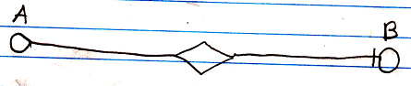

The fact, that the lines are solid, expresses, that it is an object assignment. Other types of assignment get different line types. The access mark indicates the direction. The target object of symbol A is assigned to symbol B.

If you must have a character symbol for an object assignment, that distinguishes it from the other assignment types, it is a mix of an = and the letter o, which stands for object.

This symbol is the identifier for object assignment. You can also express it as o=.

See also: Assignment in a Diagram, Object Assignment

Author & Copyright: Jan-Joost van Zon Date: May 24, 2008 – July 12, 2008 Location: Oosterhout, The Netherlands Status: Finished

